**DATABASE DESIGN DOCUMENT**

1. **Introduction**

In the process of developing management system for Sportify event, a data storage solution needs to present in order to make the event successfully organized and manageable due to large number of expected visitors. Thus, G5 has come up with the following database design to tackle the issue.

All data are stored in MySQL database management system running on Ubuntu 14.04 web server. Access to the database will be through a website and several windows applications. This design is to provide easy data entry access and information querying to visitors and event administrators.

1. **The Design**
   1. **EER Diagram**

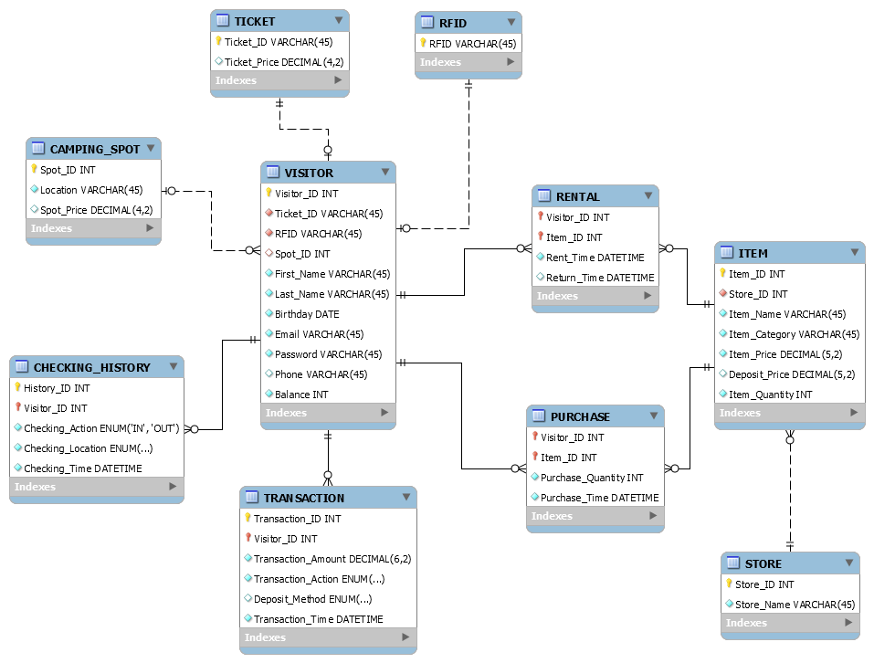

* 1. **Tables**

The contents below are details about all tables in the database.

* + 1. **VISITOR Table**

This table stores data about visitors coming to the event.

|  |  |  |  |  |  |
| --- | --- | --- | --- | --- | --- |
| **Column Name** | **Key** | **Data Type** | **Default Values** | **Allow Null** | **Description** |
| *Visitor_ID* | Primary | Integer |  | No | Unique identity number |
| *Ticket_ID* | Foreign (TICKET) | Varchar(45) |  | No |  |
| *RFID* | Foreign (RFID) | Varchar(45) |  | No |  |
| *Spot_ID* | Foreign (CAMPING_SPOT) | Integer |  | Yes |  |
| *First_Name* |  | Varchar(45) |  | No | Visitor’s first name |
| *Last_Name* |  | Varchar(45) |  | No | Visitor’s last name |
| *Birthday* |  | Date |  | No | Visitor’s birthday |
| *Email* |  | Varchar(45) |  | No | Visitor’s email address |
| *Password* |  | Varchar(45) |  | No | Encrypted password for visitor’s event-account |
| *Phone* |  | Varchar(45) |  | Yes | Visitor’s phone number |
| *Balance* |  | Integer | 0 | No | Balance of event-account |

* + 1. **TICKET Table**

This table stores data about event tickets and their prices.

|  |  |  |  |  |  |
| --- | --- | --- | --- | --- | --- |
| **Column Name** | **Key** | **Data Type** | **Default Values** | **Allow Null** | **Description** |
| *Ticket_ID* | Primary | Varchar(45) |  | No | Unique identifier (This ID is used to generate QR code on visitor’s e-ticket) |
| *Ticket_Price* |  | Decimal(4,2) |  | Yes | Ticket’s Price |

* + 1. **RFID Table**

This table stores data about bracelets used for identification purpose during the event.

|  |  |  |  |  |  |
| --- | --- | --- | --- | --- | --- |
| **Column Name** | **Key** | **Data Type** | **Default Values** | **Allow Null** | **Description** |
| *RFID* | Primary | Varchar(45) |  | No | Unique identifier of RFID chip |

* + 1. **CAMPING_SPOT Table**

This table stores data about all camping spot available during the event.

|  |  |  |  |  |  |
| --- | --- | --- | --- | --- | --- |
| **Column Name** | **Key** | **Data Type** | **Default Values** | **Allow Null** | **Description** |
| *Spot_ID* | Primary | Integer |  | No | Unique identifier |
| *Location* |  | Varchar(45) |  | No | Location of the spot |
| *Spot_Price* |  | Decimal(4,2) |  | Yes | Price of the entire camping spot (includes €10 reservation cost and €20 each person. If payment is not made, plus €10 additional fee) |

* + 1. **CHECKING_HISTORY Table**

This table stores data about visitor’s check-in, check-out action during the event.

|  |  |  |  |  |  |
| --- | --- | --- | --- | --- | --- |
| **Column Name** | **Key** | **Data Type** | **Default Values** | **Allow Null** | **Description** |
| *History_ID* | Primary | Integer |  | No | Unique identifier |
| *Visitor_ID* | Foreign (VISITOR) | Integer |  | No |  |
| *Checking_Action* |  | Enum | IN, OUT | No | This field indicates a visitor check-in or check-out |
| *Checking_Location* |  | Enum | ENTRANCE, CAMPING | No | This field indicates a visitor check-in or out of entrance or camping area |
| *Checking_Time* |  | Datetime |  | No | Time when a visitor check-in or out of the event |

* + 1. **TRANSACTION_HISTORY Table**

This table stores data about all transactions that are made during the event.

|  |  |  |  |  |  |
| --- | --- | --- | --- | --- | --- |
| **Column Name** | **Key** | **Data Type** | **Default Values** | **Allow Null** | **Description** |
| *Transaction_ID* | Primary | Integer |  | No | Unique identifier |
| *Visitor_ID* | Foreign (VISITOR) | Integer |  | No |  |
| *Transaction_Amount* |  | Decimal(6,2) |  | No | Amount of money |
| *Transaction_Action* |  | Enumeration | DEPOSIT, PAYMENT, WITHDRAWAL | No | This field indicates a visitor deposit, withdraw money or make payment |
| *Deposit_Method* |  | Enumeration | ONLINE, ATM | Yes | This field indicates a visitor deposit, withdraw money using online event-account or onsite ATM |
| *Transaction_Time* |  | Datetime |  | No | Time when a transaction is made |

* + 1. **STORE Table**

This table stores data about stores in the event.

|  |  |  |  |  |  |
| --- | --- | --- | --- | --- | --- |
| **Column Name** | **Key** | **Data Type** | **Default Values** | **Allow Null** | **Description** |
| *Store_ID* | Primary | Integer |  | No | Unique identifier |
| *Store_Name* |  | Varchar(45) |  | No | Store name |

* + 1. **ITEM Table**

This table stores data about all sale and loan items in the event.

|  |  |  |  |  |  |
| --- | --- | --- | --- | --- | --- |
| **Column Name** | **Key** | **Data Type** | **Default Values** | **Allow Null** | **Description** |
| *Item_ID* | Primary | Integer |  | No | Unique identifier |
| *Store_ID* | Foreign (STORE) | Integer |  | No |  |
| *Item_Name* |  | Varchar(45) |  | No | Sale or loan item name |
| *Item_Category* |  | Varchar(45) |  | No | Type of item |
| *Item_Price* |  | Decimal(5,2) | 0 | No | Item price |
| *Deposit_Price* |  | Decimal(5,2) |  | Yes | Deposit amount requires to be paid when renting an item (can be null if an item is for sale not for loan) |
| *Item_Quantity* |  | Integer | 0 | No | Number of items in stock |

* + 1. **PURCHASE Table**

This table stores data about all purchases made by visitors during the event.

|  |  |  |  |  |  |
| --- | --- | --- | --- | --- | --- |
| **Column Name** | **Key** | **Data Type** | **Default Values** | **Allow Null** | **Description** |
| *Visitor_ID* | Foreign (VISITOR) | Integer |  | No |  |
| *Item_ID* | Foreign (ITEM) | Integer |  | No |  |
| *Purchase_Quantity* |  | Integer |  | No | Number of items bought by a visitor |
| *Purchase_Time* |  | Datetime |  | No | Time when a purchase is made |

* + 1. **RENTAL Table**

This table stores data about all visitor’s rentals during the event.

|  |  |  |  |  |  |
| --- | --- | --- | --- | --- | --- |
| **Column Name** | **Key** | **Data Type** | **Default Values** | **Allow Null** | **Description** |
| *Visitor_ID* | Foreign (VISITOR) | Integer |  | No |  |
| *Item_ID* | Foreign (ITEM) | Integer |  | No |  |
| *Rent_Time* |  | Datetime |  | No | Time when a visitor rents an item |
| *Return_Time* |  | Datetime |  | Yes | Time when a visitor returns an item (can be null if visitor not yet return the item) |